

Consultant Pre-Course Material
Expanse Mandatory Training
A quick guide to reviewing, documenting and ordering
July 2025

Doctor’s Handbook
Contents

- Accessing and Reviewing the Patient’s Chart
- Documenting in Expanse
- Ordering Tests and Medications
- Multi-Route prescribing
- Frequency and timing
- For Anaesthetists
- For Critical Care Consultants
- Support and further resources

- Accessing and Reviewing the Patient’s Chart

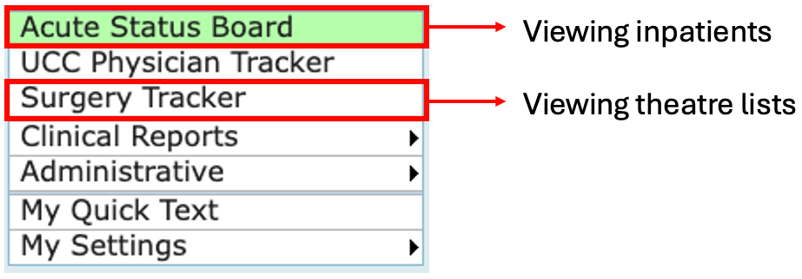
To access the patient’s chart:

- From the main menu, click Acute Status Board to view inpatients. This can be filtered by location or provider
- Click Surgery Tracker only to view theatre lists, you can option filter by location, surgeon and date to view the lists
- Alternatively, search for a specific patient in the Acute Status Board by name or hospital ID by clicking Find Patient (top right)
- Once you select the patient, the banner will be highlighted in green.

To review the patient’s chart:

- Use the black task bar to navigate to patient Chart, Document and Orders


- Click Chart to review the patient’s chart
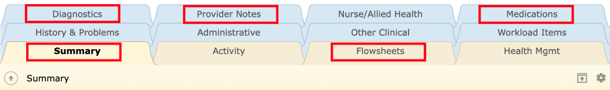

- Click on the tabs at the top of the chart:

  - Diagnostics – review blood results, imaging reports, microbiology etc
  - Provider Notes – review admission notes, op notes, progress notes etc
  - Medications – review list of home medications
  - Flowsheets – review vital signs
  - Summary – consists of widgets, including patient demographics, contact details, medical history and home medications.

The Reference Bar on the right-hand side shows important information including the DNAR status of the patient, allergies, location etc.

- Documenting in Expanse

- Click on the Document button within the black navigation bar

- Use the search bar to find specific documents
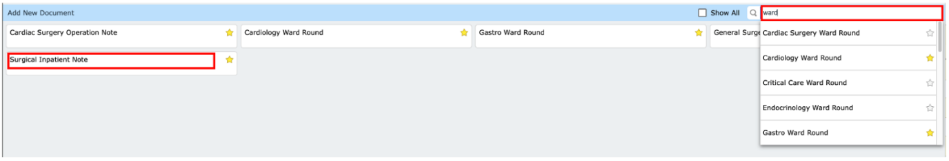
- Click the star on the right to favourite this document so that it appears as default in the future (e.g. Surgical Inpatient Note above)

- Click on the required document. The document will open as shown below:

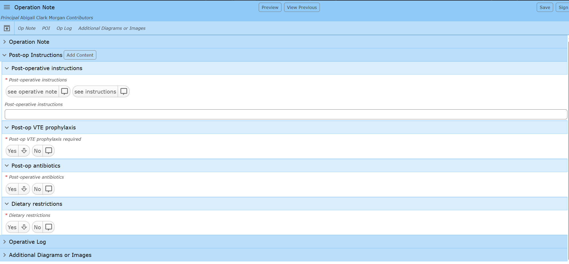

- Open each collapsed section and document by clicking or typing in the relevant boxes as above
- Within a text box, clicking the ‘A’ (top left) will give access to Quick Text. This allows you to save templates/text for use in future documents (e.g. notes for routine procedures/operations)

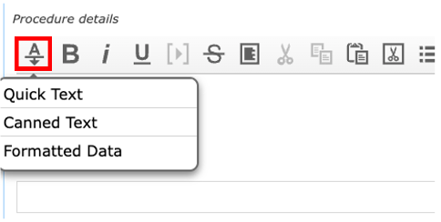

- Mandatory fields are indicated by the red Asterix – commonly found in the ‘diagnosis and plan’, post-operative instructions’ and ‘additional diagrams or images’ sections
- Click Sign (top right) and enter your pin. The signed document will save to the Provider Notes tab.

- Ordering Tests and Medications

- Click on the Orders button within the black navigation bar

- A list of the current orders will appear. Click Enter to add a new order
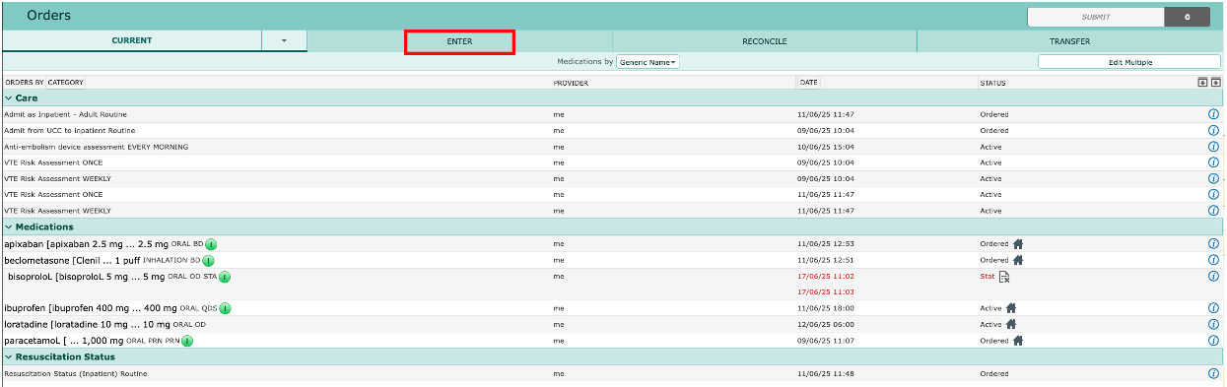
- Search for the required test/medication via the search bar. You can add this to your favourites by clicking the star on the right-hand side
- Medications are denoted by the Rx logo on the left-hand side
- Once the correct order has been selected, click on the red arrow to complete all required fields, as denoted by the red asterisk

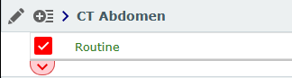

- Once all details have been entered, click Submit in the top right-hand corner.


- If all required fields have not been completed, click Next Req Field to enter the relevant information
- Finally, click Save and enter your pin to complete the order
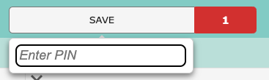

- The order will now be visible in the Current tab of the Orders section.

- Multi-Route prescribing

- To prescribe the same medication across multiple routes (e.g.PO and IV) you must prescribe separate orders and then link them.

How to link:

- Order the medications using your PIN
- Go to the ‘Current Orders’ page and click ‘Edit Multiple’.
- Select ‘Link/Unlink’

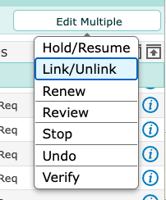

- Use the ‘ENTER NEW LINKS’ tab and click the check boxes to link your medications
- Select ‘Concurrent’ and then Save

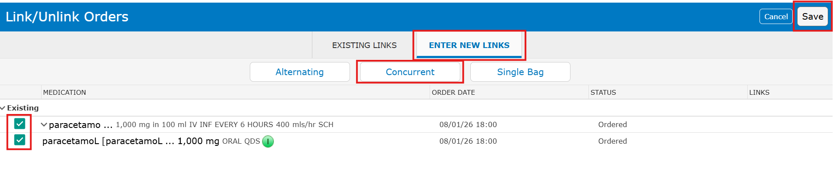
- A chain icon will appear in the status column and MAR when successfully linked

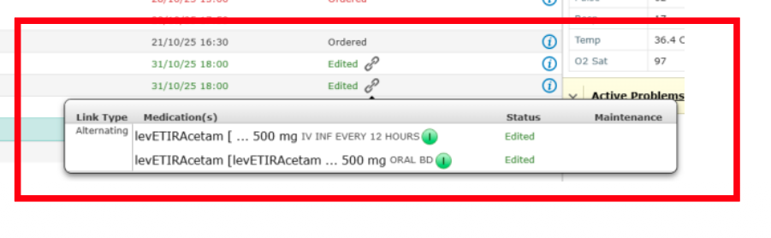

- Frequency and timing

Once-Daily (OD) Meds:

- OD medications default to 0600 in the MAR
- If an urgent first dose is needed outside of that time you MUST change the frequency to ‘EVERY 24 HOURS’
- This avoids unsafe dosing intervals

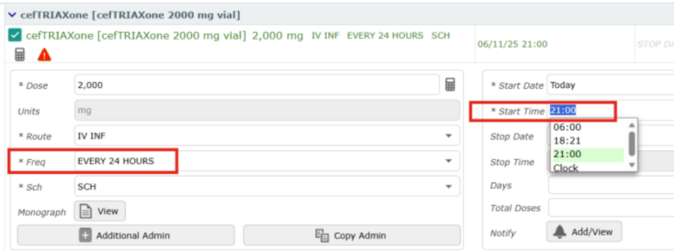

Multiple daily doses:

- Prescribing multiple daily doses can by done by setting the Frequency to BD, TDS, QDS and leaving the Sch box as SCH
- This method defaults the administration times to 06:00, 12:00, 18:00, 22:00 for QDS for example

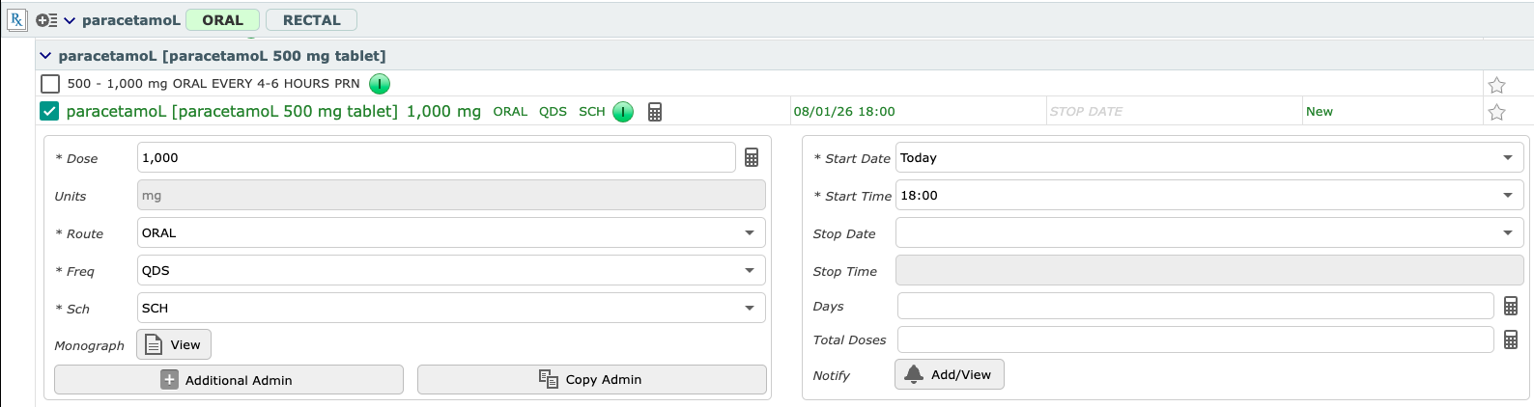
Altering administration times:

- To prescribe multiple daily doses at specific (non-default) times, edit the Freq box to the specific times required in 24 hours format with commas separating and no spaces (e.g. 0600,1300,1900,2300)
- Leave the Sch box as SCH

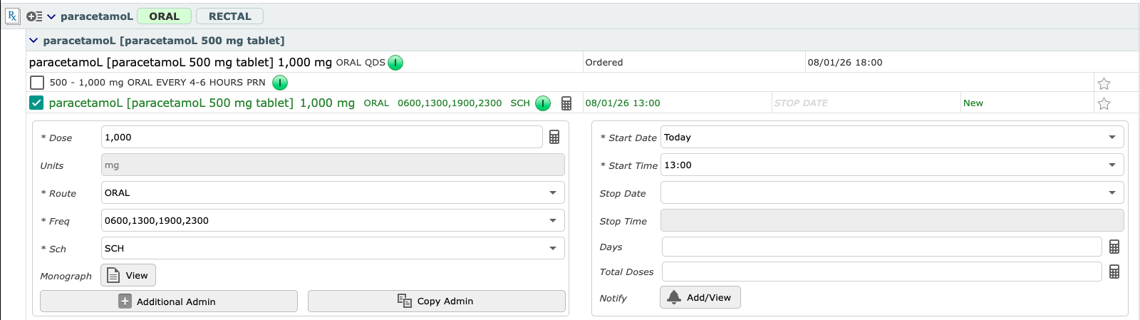
STAT dosing

- If an urgent one-off medication is required, use frequency of ‘ONCE’ and Sch of ‘ONE’ instead of STAT
- STAT orders automatically discontinue, regardless of whether they have been administered or not, and cannot be prescribed for a later time.

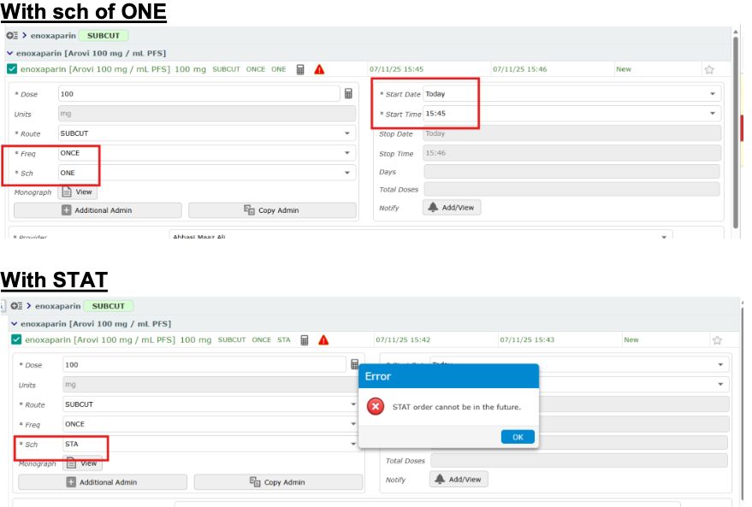

- For Anaesthetists

- Medications given intra-operatively and as part of the Anaesthetic do not need to be entered on Expanse. The prescription on the anaesthetic chart is sufficient and will be scanned into the electronic chart on discharge.

- High- risk medications:
  - The exceptions are high-risk medications such as paracetamol, NSAIDs, antimicrobials, and anticoagulants which need to have their next dose time corrected to account for any dose(s) given intra-operatively.
  - For example, if paracetamol is given intra-operatively at 11am, prescribe your next post-op dose to commence at 5pm.
  - Change the frequency to “Q6H” to alter the nursing schedule based on the new post-op administration time.
  - **CONFIRM THIS IS APPROVED BY PHARMACY BEFORE DISSEMINATING**

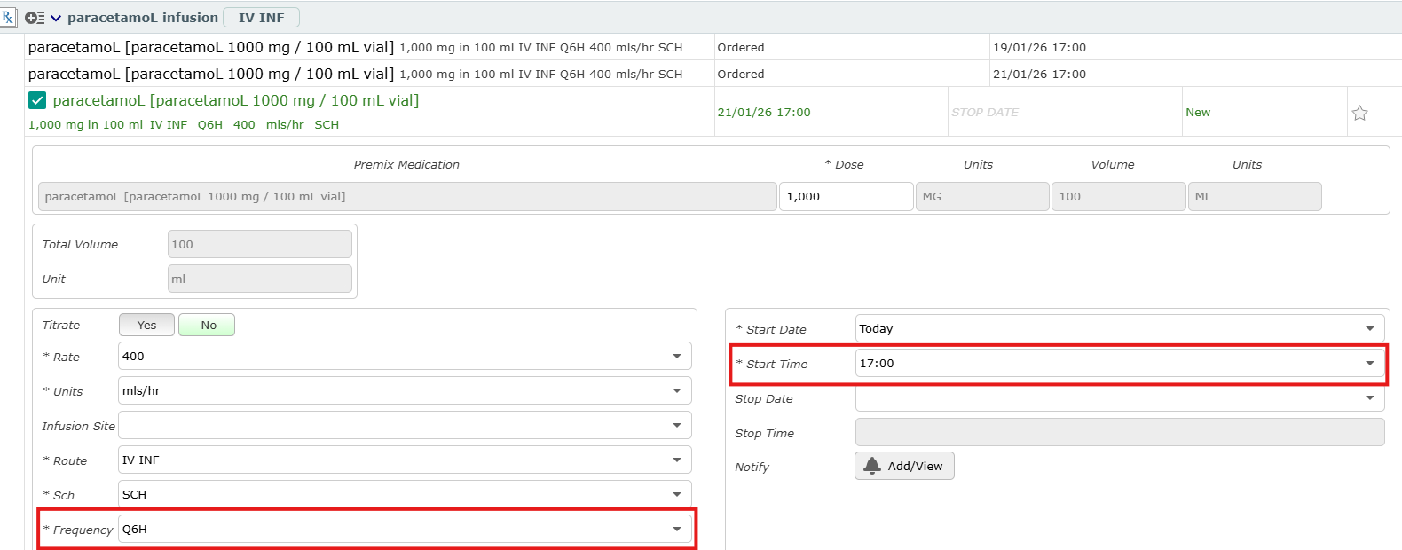
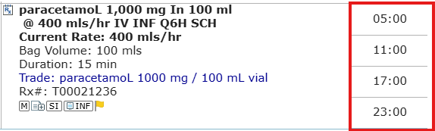

- When prescribing a specific number of doses of a post-op medication e.g. antibiotics, change the start time to reflect any doses given intra-operatively, state the total number of doses to be given and additionally change the frequency to the format of Q6H/Q8H/Q12H (whichever is appropriate for that drug).

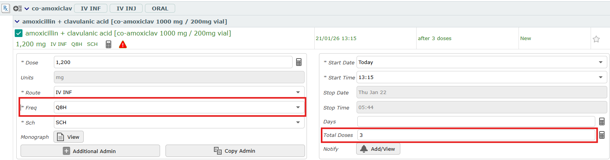
- This will update the MAR with the new drug administration time based on the intra- operative doses and the total number of doses to be given:

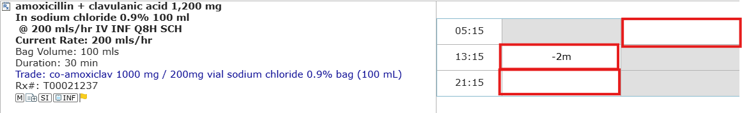

- Post-Op Medications:
  - The ‘Anaesthetics Post Op (ADULT)’ order set contains common post-operative prescriptions including medications for Recovery.
  - Use the tickboxes to select the drugs you wish to prescribe and alter the dose/frequency as required.
  - Other medications can be ordered individually in addition to the order set.
  - You can favourite commonly used drugs for efficiency by selecting the star icon next to the drug.

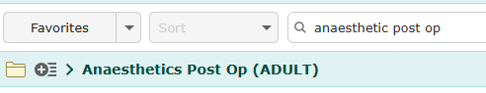

- Epidurals:
  - Type Epidural into the search bar and select a plain or mixed infusion.
  - Select the desired infusion based on your facility.
  - Ensure details such as the starting rate are configured.
  - The Titrate field must be set to ‘No’ to avoid additional steps during administration. Nursing staff can still titrate the rate on the MAR even if this is set to No.
  - Naloxone is pre-selected as part of the epidural order set in line with policy. You can adjust the dose by expanding the order details.

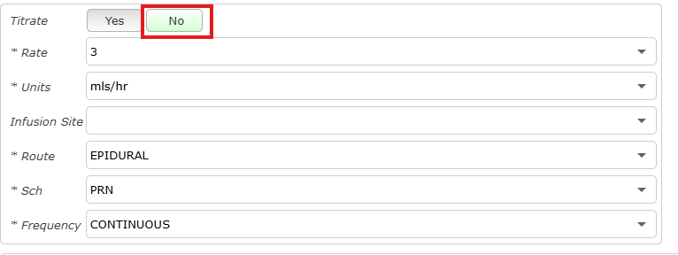

- PCAs:
  - Type ‘PCA’ into the search bar, select your facility and choose the desired PCA drug and concentration you wish to prescribe.
  - PCA infusions are built without a default basal rate, in line with corporate policy. If a background dose is clinically required, enter the rate in the “Basal Rate” field; otherwise, enter ‘0’ to indicate no background infusion.
  - Review the bolus dose and lockout interval, and adjust as needed.
  - Naloxone is pre-selected as part of the PCA order set in line with policy. You can adjust the dose by expanding the order details.

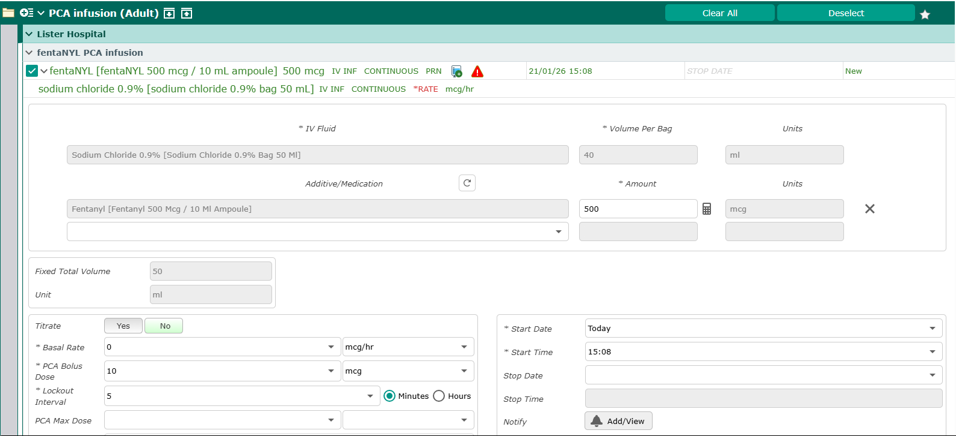

- Difficult airway:
  - If a difficult airway is encountered, complete the ‘Anaesthetic Airway Alert’ document.
  - You must also add Difficult Airway as a Special Indicator which will alert future caregivers on opening the patient chart.
  - This can be added via the Special Indicator widget on the Summary page.

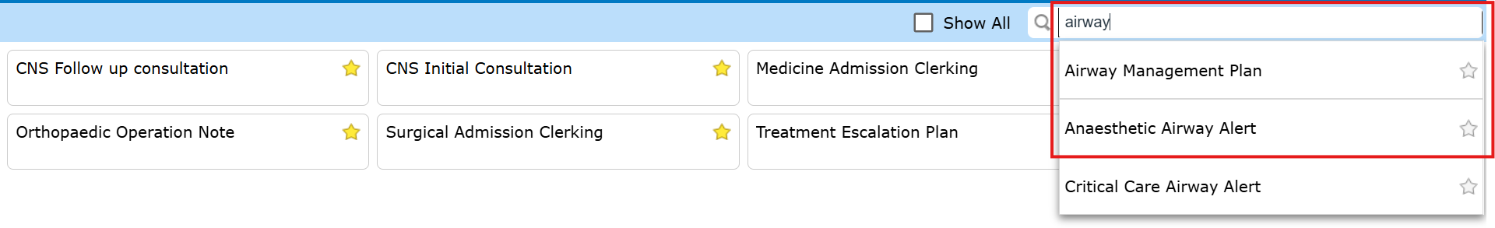

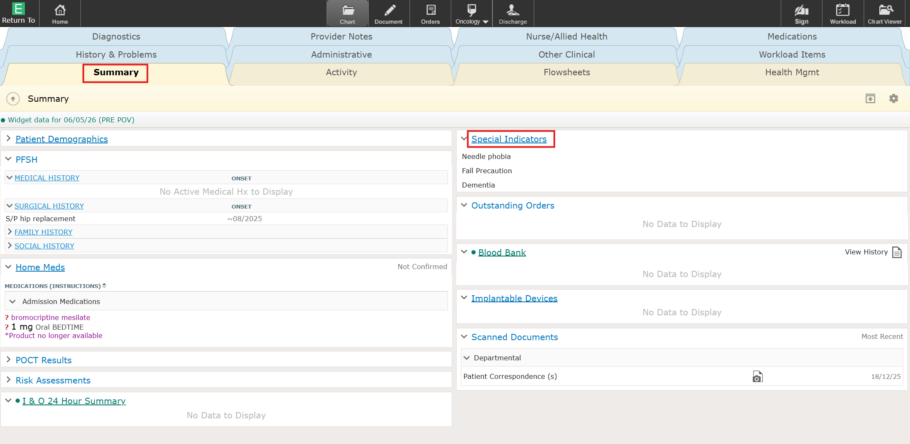
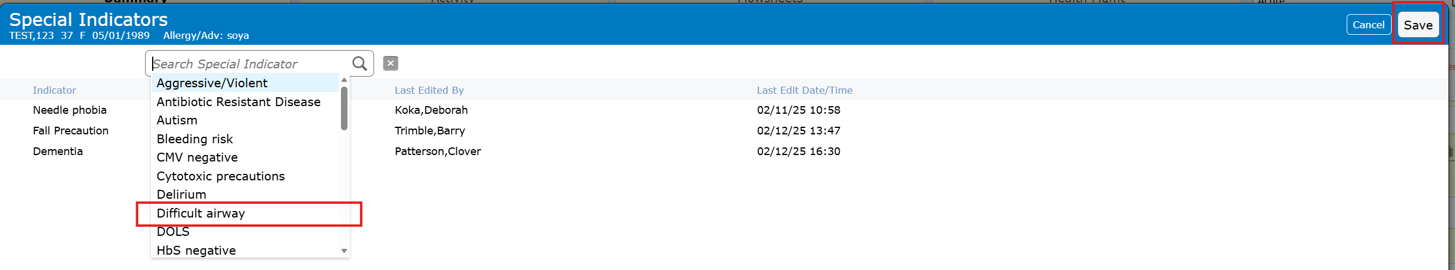
- Coverage:
  - If you regularly work with the same surgeon(s) you can set up your ‘coverage’, so their lists automatically show in your Rounds Patients to save manually searching for their list.

- For Critical Care Consultants

- Daily Reviews: Use the "Crit Care Consultant Review" template for documenting reviews:

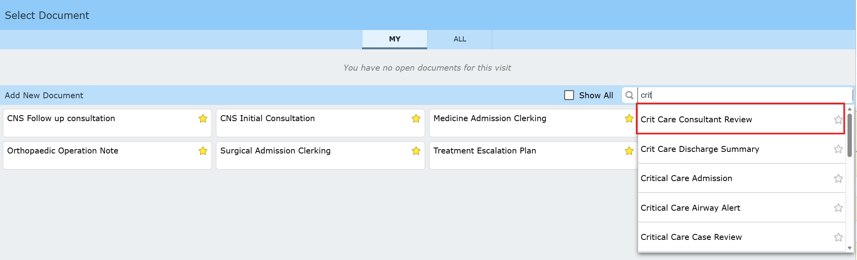
- Flowsheets are used to view the patient’s observations and trends over time. All ICU flowsheets begin with "CC" (except for "Tubes, lines and drains"):

- 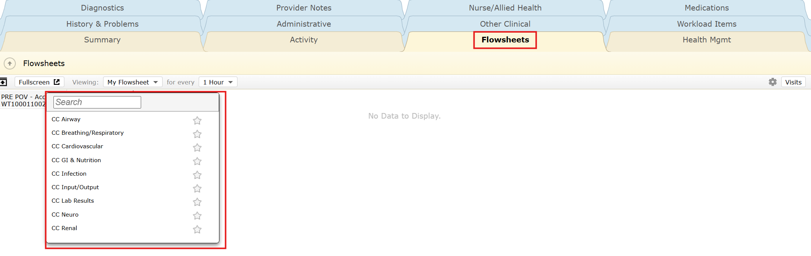

- Fluid Balance: To view 24h and length of stay fluid balance, use the "I&O 24 Hour Summary" widget in the Summary tab:

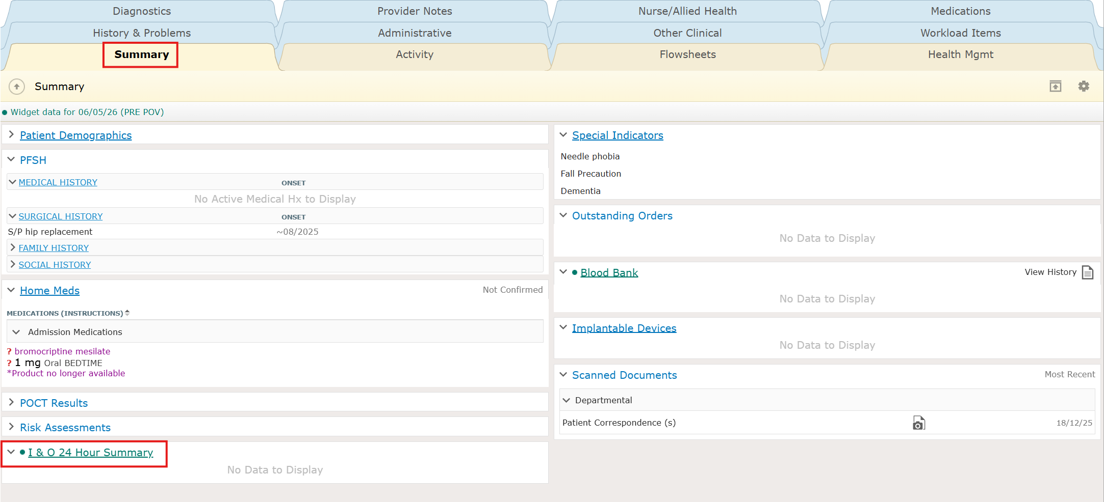

- ICU prescribing:
  - There are order sets specific to each site which replicate those previously used in ICCA.
  - Type“ICU” in the search bar within the Orders section to view all available order sets.
  - Use the tickboxes to select the drugs you wish to prescribe.
  - Drugs appearing in red will require further information input to complete the prescription e.g. for maintenance fluids you will need to specify the hourly administration rate.

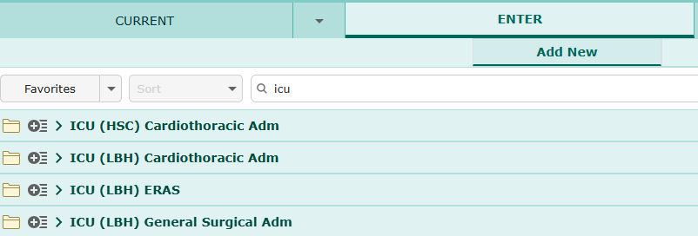
- If you wish to prescribe an ICU infusion without using the order set, enter the required drug within the search bar.
- Always select the option that has “IV INF” next to the drug name and has a diluent section attached to the prescription (see below) – this ensures the volume of drug administered is included in the patient’s fluid balance.

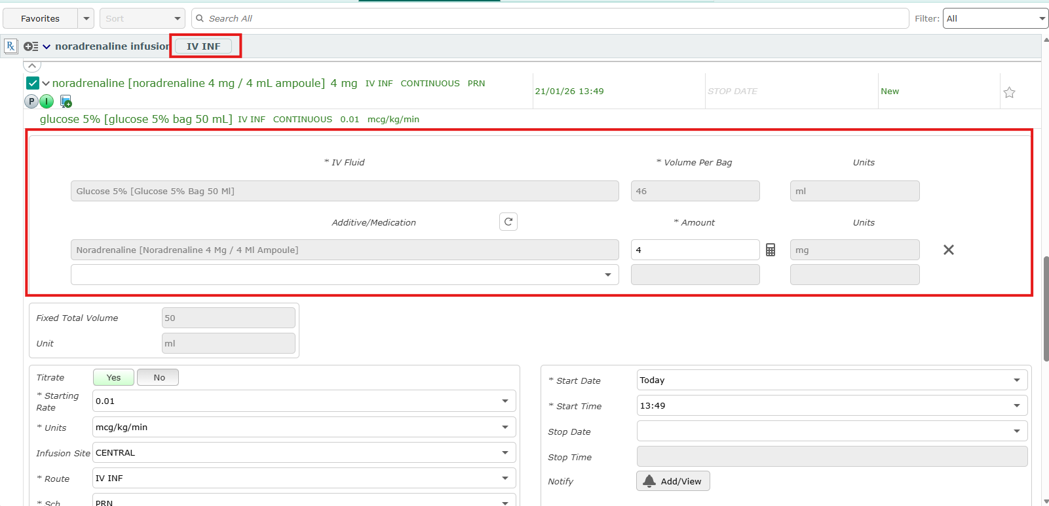

- Support and further resources

Crib sheets and refresher videos can be accessed via the Consultant knowledge hub (no need to log in): Expanse: Consultant Hub

