

Carbon Reduction Plan
March 16, 2026

Our commitment to achieving net zero
At HCA Healthcare UK, we’re committed to the care and improvement of human life. We believe that our own health and the health of our planet are linked, so reducing our environmental impact is important to our mission.

With that in mind, we’ve set out an environmental sustainability strategy and a target of being a net zero business by 2035 for scope 1 and 2 emissions, and by 2045 for scope 3 emissions.

Our sustainability strategy
Acting to reduce our carbon emissions and investing in the long-term health of our planet is part of our work to ensure a healthy future for everyone. Our Environmental Sustainability Strategy at HCA UK sets a vision for sustainability that includes both net zero and nature positive goals.

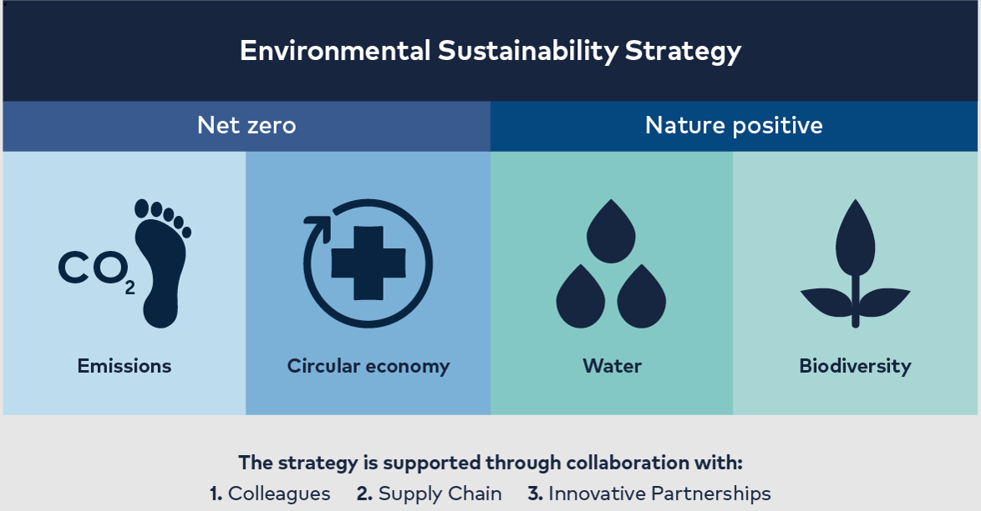

Our baseline emissions footprint
Baseline Year: 2024
Additional details relating to the baseline emissions calculations.
While we’ve been measuring emissions for scope 1 and scope 2 since 2021, we began measuring scope 3 emissions in 2023. We are updating our baseline year to reflect wider work on scope 3 calculations and external assurance.
We use operational control to define our scope for this report: our operational boundary includes activities from our locations operating in the United Kingdom.
Baseline year emissions (2024):
EMISSIONS | TOTAL (tCO₂e)
Scope 1 | 8,649.22
Scope 2 (market-based) | 24,734.87
Scope 2 (location-based) | 11,216.34
Scope 3  (Included sources) | 16,437.17  Comprised of:  - Fuel- and Energy Related Emissions: 7,735.39  - Upstream Transport and Distribution: 527.07  - Waste: 410.91  - Business Travel (including hotel stays): 2,277.03  - Employee Commuting (including homeworking): 5,486.77  - Downstream Transportation and Distribution: 0.01
Total emissions | 49,821.27

Our current emissions reporting
Reporting Year: 2024
Additional details relating to the 2024 emissions calculations.
We use operational control to define our scope for this report: our operational boundary includes activities from our locations operating in the United Kingdom.
We applied the WRI/WBCSD Greenhouse Gas Protocol: Corporate Accounting and Reporting Standard (revised edition) and the WRI/WBCSD Greenhouse Gas Protocol: Corporate Value Chain (Scope 3) Accounting and Reporting Standard.
EMISSIONS | TOTAL (tCO₂e)
Scope 1 | 8,649.22△
Scope 2 (market-based) | 24,734.87△
Scope 2 (location-based) | 11,216.34△
Scope 3  (Included Sources) | 16,437.17△  Comprised of:  - Fuel- and Energy Related Emissions: 7,735.39  - Upstream Transport and Distribution: 527.07  - Waste: 410.91  - Business Travel (including hotel stays): 2,277.03  - Employee Commuting (including homeworking): 5,486.77  - Downstream Transportation and Distribution: 0.01
Total emissions | 49,821.27
△ This indicates that the data was subject to external independent limited assurance by Ernst & Young LLP ('EY'). See https://www.hcahealthcare.co.uk/environmental-sustainability/reporting for EY’s assurance statement.

Our emissions reduction targets
We are working to achieve net zero by 2035 for scope 1 and 2 emissions, and by 2045 for scope 3 emissions.

In the short term, we’re pursuing a plan to reduce our scope 1 and 2 emissions by 50% by 2030. We’re also developing our understanding of our scope 3 emissions so that we can make meaningful, data-driven reductions where clinically safe and fiscally prudent to do so.

Our carbon reduction projects
Completed carbon reduction initiatives
Throughout 2024, we worked alongside our clinical teams to complete or implement a range of environmental management measures, including:
- In January 2024, we stopped buying desflurane, a volatile surgical anaesthetic gas associated with high greenhouse gas emissions
- Our primary care team achieved a Gold Certification from the Green Impact for Health Toolkit. In primary care, we also drove a campaign to prescribe low-carbon inhalers where clinically appropriate, achieving a rate of 48% dry powder inhaler uptake in Q3 of 2024, an increase of 11% on 2023
- We launched pilots to reduce our clinical consumables where clinically safe to do so, including:
  - Introducing reusable theatre caps
  - Reducing our paper couch roll usage
  - Reducing our glove usage
  - Introducing reusable blood pressure cuffs

We ran a programme to improve our waste segregation and management, which included:
- Achieving improved ‘offensive waste’ segregation and adherence to the National Clinical Waste segregation targets set for the NHS by 2026, which saved over 107 tonnes of CO2e
- Rolling out additional recycling infrastructure across our hospitals, improving non-clinical recycling rates by 14%
- Undertaking initiatives to reduce what gets thrown away, such as reducing single use items in catering and housekeeping

In our buildings, we:
- Ran two net zero building audits and several additional Energy Savings Opportunity Scheme (ESOS) audits to understand our long-term plan for our buildings and conducted our first embodied carbon assessment
- Upgraded our eligible chillers, reducing their energy consumption by approximately 25%
- Our new buildings and retrofits have been fitted with low-carbon technology where possible, including:
  - Heat pumps
  - Waste energy recovery systems, such as run around coils and plate heat exchangers
  - Independent control valves on low temperature hot water and chilled water
  - LED luminaires with dimmable controls
  - Passive infrared sensor control of luminaires, where appropriate
  - Separately metered power and lighting boards
  - Intelligent automatic controls systems to manage the operation of all plants and associated systems

To support staff engagement and increase understanding within our business, we ran engagement weeks and days with staff, launched a Green Champions Network, and improved our training offering.

In progress and upcoming initiatives

We have a number of initiatives upcoming or already in progress in 2025:
- We are implementing a new electronic health record system, which we believe will help significantly reduce our paper processes. In conjunction with this, we also intend to run sustainability staff engagement initiatives to reduce paper.

- In our buildings, we plan to:
  - Continue to invest in modernising our buildings and upgrading equipment to create energy efficiencies, such as air handling unit replacements
  - Increase our assessments of embodied carbon within new building construction and refurbishments
  - Include environmental sustainability as part of our refresh of our building design standards

- Working with our clinical teams, we plan to scale our initiatives to reduce our use of consumables in clinical settings where clinically appropriate and fiscally prudent.

- Within our Hotel Services function, we plan to reduce our single-use catering consumables where feasible. We are also innovating our housekeeping functions by using a different style mop head that reduces plastic and water use and moving to bulk toiletries to reduce plastic use and improve recyclability.

- In our Labs business, we plan to move to digitalised systems and sample transfer to reduce courier traffic and our paper burden. We are supporting My Green Lab to develop a certification tailored to clinical labs. Once complete, we plan to undertake the My Green Lab certification scheme.

- In our supply chain, we plan to include environmental sustainability and transparency questions consistently in supplier tenders and further engage our key suppliers on environmental sustainability.

Declaration
HCA Healthcare UK’s Carbon Reduction Plan has been completed in accordance with PPN 06/21 and associated guidance and reporting standard for Carbon Reduction Plans.
Our scope 1 and scope 2 emissions have been calculated in accordance with the GHG Reporting Protocol Corporate Standard, and our Scope 3 emissions calculated in accordance with the Corporate Value Chain (Scope 3) Standard . We’ve used the appropriate Government emission conversion factors for greenhouse gas company reporting.
Our emissions have been reported and recorded in accordance with the published reporting standard for Carbon Reduction Plans, including the required subset of scope 3 emissions. We’ve also reported our scope 1 and scope 2 emissions in accordance with SECR requirements.
Our Carbon Reduction Plan has been reviewed and signed off by the board of directors for HCA International Limited, who oversee UK operations for the whole of HCA Healthcare UK and its UK affiliates.

Signed on behalf of the Supplier:

16 March 2026
Date: ……………………….……….

https://ghgprotocol.org/corporate-standard
https://ghgprotocol.org/standards/scope-3-standard
https://www.gov.uk/government/collections/government-conversion-factors-for-company-reporting

